Pseudoers: WAH for Hospitals (WAH4H)
Finals Project (DFD)

Scrum Master:
Nicolas, Jhon Lloyd

Members:
Chavez, Mariyah Vanna Monique Jajurie, John Kenneth
Quibin, Elijah Josh

SSYADD SS231

Level 0 – Context Diagram
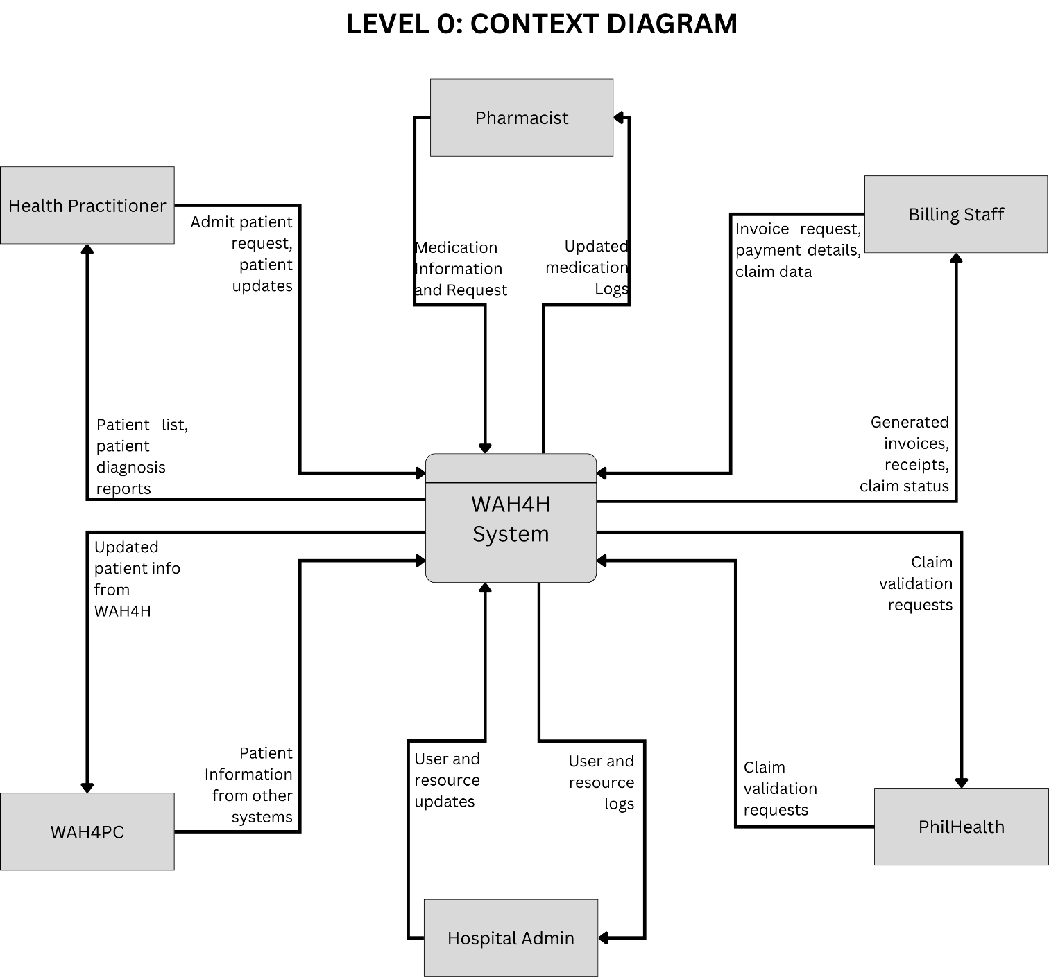
The Level 0 DFD, also known as the context diagram, provides an overview of the WAH4H System as a single process interacting with external entities. At this stage, the system is treated as a "black box" that receives inputs from Health Practitioners, Pharmacists, Billing Staff, Hospital Admins, WAH4PC, and the PhilHealth system. The system produces outputs such as patient lists, diagnosis reports, updated patient information, generated invoices, receipts, claim status, medication logs, and user/resource updates. Data stores are not yet shown here, as the focus is to establish the boundary between WAH4H and its external environment.

Level 1 – Dataflow Diagram

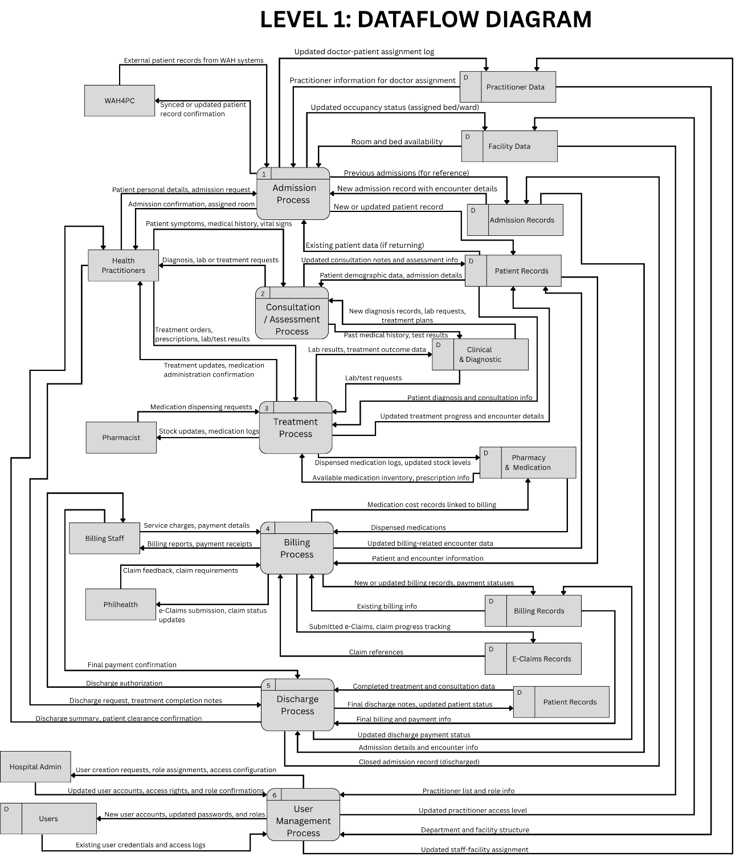
The Level 1 DFD expands the WAH4H System into its six major processes: Admission Process (1), Consultation/Assessment Process (2), Treatment Process (3), Billing Process (4), Discharge Process (5), and User Management Process (6). Each process is linked to the appropriate data stores: Admission Records, Patient Records, Clinical & Diagnostic Records, Pharmacy & Medication Data, Billing Records, E-Claims Records, Users, Practitioner Data, and Facility Data. At this level, the diagram shows how each process exchanges data with both internal data stores and external entities (WAH4PC, Health Practitioners, Pharmacist, Billing Staff, Philhealth, and Hospital Admin), while highlighting the relationships and data flows among the core modules of the system.

Level 2 – Detailed Process Breakdown

User Management
The Level 2 diagram for User Management details how Hospital Admins manage staff, users, and facility information within the system. This process includes three main subprocesses: 6.1 Manage Staff and Roles, which handles staff role assignments and practitioner details using the Practitioner Data (D) store; 6.2 Manage Users and Access, which creates, updates, or deactivates user accounts and configures access levels, interacting with the Users (D) data store; and 6.3 Update Practitioner & Facility Data, which maintains department structure, facility information, and practitioner profiles stored in Facility Data (D). The Hospital Admin initiates requests to manage staff roles, user accounts, and facility assignments, and receives confirmations of updates, access grants, new user credentials, and updated practitioner/facility records.

Admission Process
This process handles all aspects of patient admission, from initial registration to room assignment. The workflow includes three main subprocesses: 1.1 Collect Patient Info, where WAH4PC provides personal information and medical history, creating or updating patient and encounter records in the Patient Records (D) data store; 1.2 Verify Patient Info, where Healthcare Staff verifies patient information and checks existing records to ensure accuracy; and 1.3 Assign Room & Practitioner, where room and practitioner availability from Practitioner & Facility Data (D) is checked, and the patient is assigned to an appropriate room and healthcare provider. Healthcare Staff coordinates the entire admission process, receiving admission confirmations, assigned room details, and practitioner information, while patient encounter information flows into the central patient records repository.

Consultation Process
The Consultation Process focuses on clinical assessment and diagnosis during patient encounters. This process consists of three key subprocesses: 2.1 Record Vitals and Symptoms, where Healthcare Staff documents patient observations, vital signs, and symptoms, storing this information in Clinical & Diagnostic Records (D) along with demographic and encounter details from Patient Records (D); 2.2 Diagnose Condition, where Healthcare Staff analyzes recorded vitals, symptoms, and patient history to establish a diagnosis and treatment recommendations, updating the clinical records accordingly; and 2.3 Update Diagnostic Records, where diagnosis details and required lab tests are logged and made ready for laboratory processing. Healthcare Staff receives confirmations at each step and may request additional diagnostic tests, with all clinical documentation flowing into the Clinical & Diagnostic Records data store for comprehensive patient care tracking.

Treatment Process
The Treatment Process manages the ordering, dispensing, and administration of medications and treatments. This process includes three main subprocesses: 4.1 Generate Treatment Orders, where Practitioners create treatment and medication orders based on patient diagnosis and clinical notes from Clinical & Diagnostic Records (D), with updated prescriptions and treatment records stored back into the clinical records; 4.2 Dispense Medication, where Pharmacists receive medication orders and stock information, dispense medications from the Pharmacy & Medication Data (D) store, and update administered medication logs and current stock levels; and 4.3 Administer Treatment, where Practitioners administer the dispensed medications following treatment instructions, with confirmed inventory updates recorded back into the pharmacy data. Practitioners receive confirmation that medication/treatment orders are recorded and treatment administration confirmations, while Pharmacists provide dispensed medication confirmations and medication order details with stock information.

Billing Process
The Billing Process manages the calculation of charges, invoice generation, and PhilHealth claims submission. This process contains three main subprocesses: 5.1 Calculate Charges, where Billing Staff compiles service details, treatments, and administered medications from Patient Records (D) and Pharmacy & Medication Data (D) to calculate total charges, storing updated billing records in Billing & Claims Data (D); 5.2 Generate Invoice, where billing records are retrieved and formal invoices are created and stored back in the Billing & Claims Data store, with Billing Staff receiving confirmation of invoice generation; and 5.3 Process PhilHealth Claims, where claim packages are prepared using billing records and claim details, submitted to the external PhilHealth entity for validation, with updated claim status tracked in the Billing & Claims Data store. Billing Staff receives claim submission acknowledgments and confirmations of claim processing from PhilHealth, while PhilHealth performs service verification for claims validation.

Discharge Process
The Discharge Process finalizes patient care by confirming payments, preparing discharge documentation, and obtaining necessary clearances. This process includes three main subprocesses: 5.1 Confirm Payment & Billing, where billing records and payment status from Billing & Claims Data (D) are verified and updated billing records are stored to ensure all financial obligations are settled; 5.2 Prepare Discharge Summary, where treatment logs, lab results, and consultation notes from Patient Records (D) along with encounter details and clinical notes are compiled into a comprehensive discharge summary, with updated patient discharge information stored back in Patient Records; and 5.3 Obtain Patient Clearance, where the Health Practitioner reviews the discharge summary and instructions, provides approval of patient discharge, and the system confirms completion of the discharge summary. The Health Practitioner coordinates the final discharge authorization, ensuring all clinical and administrative requirements are met before the patient leaves the facility.

